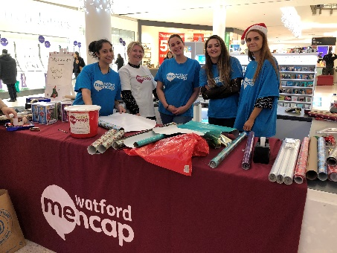

About Us
Watford Mencap supports over 800 people with learning disabilities and their families in South West Herts. We are affiliated to Royal Mencap but are a self-funding and independent local charity that has provided services and support to local families for the past 70 years.
We currently operate across 11 sites in Hertsmere, Three Rivers and Watford, owning 6 of these properties. During 2021 we shall bring together our head office and children’s centre into a newly acquired building which will become an exciting new central hub for the charity in Watford. Over the next 3-5 years we shall expand and develop this hub into a multipurpose site used by the charity and other local groups.
We are proud to have a strong presence in the local voluntary sector, and you will be joining a small but dedicated team, representing our charity to the local community.
We are seeking a self starter who may not necessarily have previous fundraising experience. The most important aspect of this role involves working with the Fundraising Manager to grow and develop opportunities with existing and new group and individual supporters to increase voluntary income.
You will be confident talking to and engaging with people at all levels. Whether talking to a service user, corporate sponsor, a group of students or a long-standing volunteer, your enthusiasm for Watford Mencap will shine through.
You will relish the variety this role brings: recruiting volunteers, sourcing raffle prizes, organising public events, creating social media content and much more.
With your creativity, energy, communication skills and proactive way of working, you will be an asset to the Fundraising Team. With on-the-job support provided at Watford Mencap, you will be able to use and grow your talents to make a tangible difference to people with learning disabilities.
You will need a broad experience of fundraising or equivalent transferable skills. You must have excellent interpersonal skills as well as flexibility, creativity and great organisation skills.
We offer excellent terms and conditions of employment.

OUR VALUES
At Watford Mencap we bring everyone together with our shared values, and they guide the way we work:
We are INCLUSIVE. People with learning disabilities are at the heart of everything we do.

We are RESPECTFUL. We work in a person centred way, whilst listening to the views of all.

We are WELCOMING. We are approachable and value all.

We are PROGRESSIVE. We promote learning to support everyone to achieve their potential.

We are CHALLENGING. Through our work we will push the boundaries for individuals, organisations and society.

Job Description: Fundraiser, full time

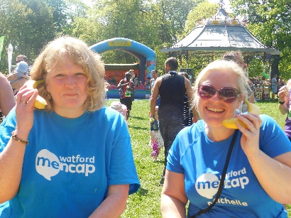

Reports to: Fundraising Manager
Based at our Head Office in South West Hertfordshire (currently Rickmansworth, will be central Watford from late summer 2021)
Main purpose of the role:
To work with the Fundraising Manager to develop and deliver fundraising and income generation activities including events, written applications, supporting volunteers, managing external relationships.
Main duties and responsibilities
- Developing and delivering activities which contribute towards Watford Mencap’s income generation strategy including events, digital and community fundraising.
- Building and maintaining positive external relationships with a range of stakeholders, including local business and corporate contacts, community groups, volunteers, supporters and donors to maximise income and other support eg gifts in kind, volunteer time etc.
- Produce post event evaluations and future recommendations.
- Ensure accurate records are kept up to date on our Salesforce CRM database.
- Contributing to Watford Mencap’s communications and social media strategy including event-related marketing materials, publications, website and online channels.
- To actively encourage and expand the use of volunteers to support the work of the department
- To actively promote and work within Watford Mencap’s equal opportunities and diversity policy
- Deliver first class support to new and current volunteer fundraisers
- Provide support and guidance to those undertaking initiatives to raise money and endeavour to secure long-term support from these people.
- To be self sufficient in own administration using relevant IT
- To take responsibility for own performance and personal development, actively seeking opportunities to train, network, project manage whilst keeping up to date with developments in the field
- Work collaboratively with all teams at Watford Mencap to ensure all income streams are maximised by sharing contacts and networks and work closely with colleagues to involve them in fundraising activities as required.
- Work to support the mission, ethos and values of Watford Mencap
- Abide by organisational policies, codes of conduct and practices.
- Treat with confidentiality any personal, private or sensitive information about individual organisations and/clients or staff at Watford Mencap.
- To undertake such additional duties as required.

Person Specification:
 | Qualities Required | Essential/ Desirable
Education & qualifications | Good IT skills and experience using Microsoft Windows. | Essential
 | High level of numeracy, accuracy and an eye for detail | Essential
 | Full driving licence and own vehicle. The post will be based at our Head Office and will involve regular travel across Watford, Three Rivers and Hertsmere. | Essential
Experience | Understanding of the role & nature of the voluntary sector | Desirable
 | Experience of generating income, ideally in a fundraising role in a charity | Desirable
 | Knowledge of Canva, Mailchimp and Hootsuite | Desirable
 | Knowledge and understanding of key issues for people with learning disabilities and their carers | Desirable
 | Knowledge of regulatory requirements and best practice policy and guidance relating to fundraising | Desirable
 | Developing sustainable relationships across a broad spectrum of audiences. | Desirable
 | Experience of working with volunteers | Desirable
Personal Skills | Flexible ‘can do’ approach and willingness to carry out a variety of tasks, work well under direction and also use initiative and work autonomously, as required. | Essential
 | Strong communicator, both written and verbal, with the ability to inspire and enlist the support of others including formal and informal presentations. | Essential
 | Ability to maintain confidentiality | Essential
 | Ability to work as part of a team, with people at all levels, gets on well with colleagues and supporters | Essential
 | Excellent organisational skills to manage a complex workload and meet deadlines. Ability to work independently, with prioritisation skills. | Essential
 | Emotional resilience, able to remain calm when others maybe anxious | Essential
 | Able to work flexibly to occasionally include evenings and weekends to meet the demands of the job, for which notice and time off in lieu will be given where this exceeds the normal working hours | Essential
 | Ability to act as an advocate within the community, to be professional and communicate with enthusiasm, credibility, conviction and knowledge | Essential
 | Enthusiasm for new challenges and experiences. | Essential
 | Commitment to anti-discriminatory practice and equal opportunities. An ability to apply awareness of diversity issue to all areas of work. | Essential

Our Values
To be successful in this role we expect you to share and live our values:
Value | Behaviour
Inclusive | You involve the people we support by listening to them and considering their needs when organizing events so that they can participate in those events.
 | You are able to communicate effectively with people with a learning disability and your colleagues, adapting your approach to the needs of the person at the time.
Respectful | You demonstrate through your actions respect, dignity, diversity, and privacy for people we support.
 | You develop and maintain effective working relationships with managers, project staff, partner organisations, suppliers and the public.
 | You work flexibly and can adapt to changes in workload as necessary.
Welcoming | You ensure that our events can be safely accessed and used by all
 | Develop and maintain a welcoming atmosphere within our projects for the people we support and their families.
 | Provide and maintain a safe, secure, clean, warm and stimulating environment for the people we support, staff and visitors.
Progressive | Keep your fundraising and voluntary sector knowledge and skills up to date and share appropriately.
 | Able to record information, access and manipulate data stored in IT systems and share information easily and appropriately.
 | Be innovative with ideas and passionate about developing the most effective and efficient fundraising service for the charity.
 | Be able to think creatively and pro-actively to develop events and fundraising opportunities as the needs of the services and people change.
Challenging | Professionally challenge prejudices that cause barriers for people living with learning disabilities.
 | You work with the teams to manage priorities and competing demands for fundraising support.

